# **Data Statistics and Processing using R**

**R scripting language** is widely used amongst researchers for performing statistical analysis and plotting results. It has a very good community and university support. It is a GNU project. Measures of object similarity and dissimilarity and relations help learn more about data to start with.

https://www.r-project.org/

**Wordcloud/Tag cloud**

An application of plotting simply the trends with eye catching visualization is Word Cloud also known as Tag Cloud. It is an image showcasing trending words from a given domain based on their popularity. The dataset after certain cleaning applied is referred to find out words with their frequencies and given as input to the plotting library. The word cloud plotting displays beautifully the word having higher importance (i.e. frequencies/occurances) with relatively more bold and bigger font size compared to other words having lesser importance. Pictorial representation of analytics is always awesome.

Many times the fancy background of words can be used to highlight trends while celebrities are walking the red carpet or giving a pose. Many architects/interior designers use this technology to create giant wallpapers which actually convey achievements of the company in general or such important things.

**Impatient Patients learn Dermatology**

For example in the waiting lounge/behind reception a wall poster containing at a Skin Clinic, Word Cloud of dermatology keywords will make some sense to patients constructively.



**Participants’ Interest**

Another example showcasing participants' interest during a technical workshop based on commands they have practiced towards the end of the workshop using a Word Cloud during the closing ceremony.

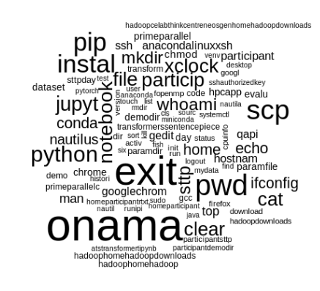

**Trending IT JOBS**

Another real life example where trending jobs in IT sector can be better displayed as below instead of just a table.

https://www.kaggle.com/datasets/saurav0507/it-job-opportunities-dataset-2019-20https://www.kaggle.com/datasets/saurav0507/it-job-opportunities-dataset-2019-2 

<https://www.kaggle.com/datasets/saurav0507/it-job-opportunities-dataset-2019-2023>

**R code to practice Word Cloud**

library("tm")

library("corpus")

library("SnowballC")

cname_jr <- file.path("/home/jigarpandya/my-dev/R/tagcloud/it-job-opportunities-dataset/data")

print(cname_jr)

print(dir(cname_jr))

text_corpus_jr <- Corpus(DirSource(cname_jr))

text_corpus_jr <- tm_map(text_corpus_jr, stripWhitespace)

text_corpus_jr <- tm_map(text_corpus_jr, content_transformer(tolower))

text_corpus_jr <- tm_map(text_corpus_jr, removeWords, stopwords("english"))

text_corpus_jr <- tm_map(text_corpus_jr, stemDocument)

text_corpus_jr <- tm_map(text_corpus_jr, removeNumbers)

text_corpus_jr <- tm_map(text_corpus_jr, removePunctuation)

dtm_jr <- DocumentTermMatrix(text_corpus_jr)

freq_jr <- sort(colSums(as.matrix(dtm_jr)), decreasing=TRUE)

head(freq_jr)

library(wordcloud)

wordcloud(names(freq_jr), freq_jr, min.freq=100)

**Exercises on Word Cloud/Tag Cloud:**

1. Computer Engineers, relate the concept of Histogram as well as Hadoop wordcount program and establish connection to WordCloud/TagCloud example technically/logically.The orientation is for now just for adjustment it seems.
2. Either using the given R code or over the web do create Word Cloud/Tag cloud for your domain of interest dataset.
3. Try to see more aspects like orientation, colors, etc to bring more insight to reality from the same single presentation.

**Know your data at a glance**

The basic statistics like mean, median, mode, IQR and others let us learn about data at a glance. These facts convey information about the dataset/sample at hand.

* Overall dispersion of data points
* Data quality and biasedness, outliers if any

R provides various library functions to perform certain operations to record tabular as well as graphical representations of same data or statistics/results.

**Practices**

#1

nyc=read.csv("nyc.csv")

nyc

summary(nyc)

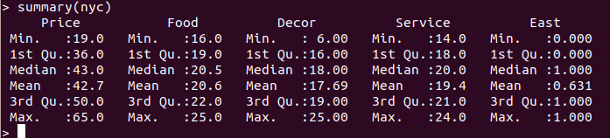

**#2**

plot(nyc,main="Pairwise scator plot")

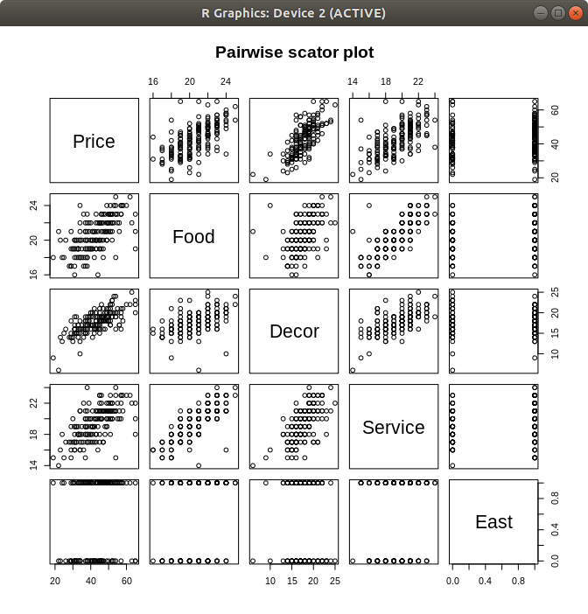

**#3**

linearMod <- lm(dist ~ speed, data=cars) # build linear regression model on full data

print(linearMod)

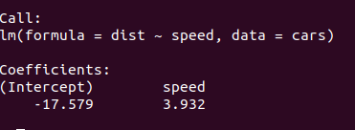

**#4**

**lm(Price~Food+Decor+Service+East,data=nyc)**

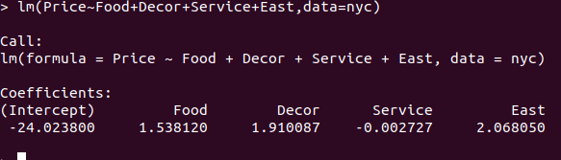

**#5**

**Rank**

The maximum number of linearly independent columns (or rows) of a given matrix is called the rank of the matrix. A higher rank indicates more independence amongst the vectors within a given matrix.

install.packages("pracma")

library(pracma)

A=matrix(data=c(1,2,8,2,9,4,5,6,8,7,3,0,5,6,6,5,5,1,10,5,6,1,0,12,1),nrow=5,ncol=5,byrow=FALSE)

A

Rank(A)

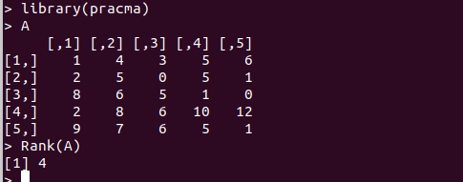

**#6**

**Eigen**

install.packages("matlab") #optional

library(matlab)

me=matrix(data=c(1,0,0,0,2,0,0,0,3),nrow=3,ncol=3,byrow=F)

me

mei=eigen(me)

mei

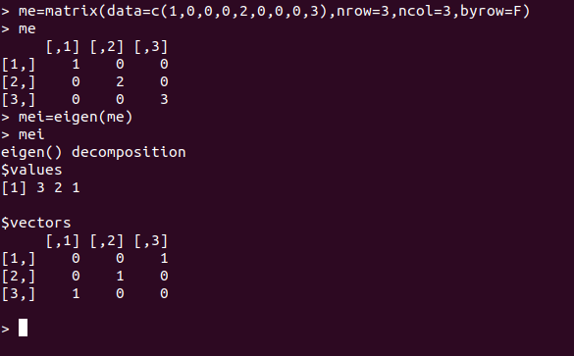

**#7**

**Central tendency of data**

**Mean (average value)**

data = c(30, 36, 47, 50, 52, 52, 56, 60, 63, 70, 70, 110)

mean(data)

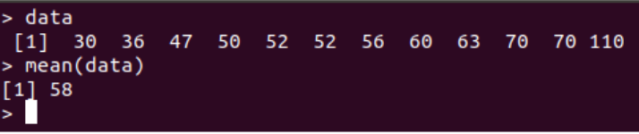

**Median (middle value)**

median(data)

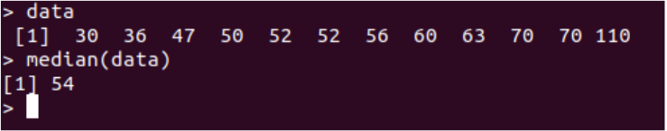

**Mode (most common value)**

package:pracma

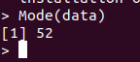

data = c(30, 36, 47, 50, 52, 52, 56, 60, 63, 70, 70, 110)

range(data)



quantile(data)

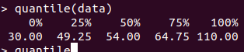

fivenum(data)

help(fivenum)

Returns Tukey's five number summary (minimum, lower-hinge, median,

upper-hinge, maximum) for the input data.



summary(data)

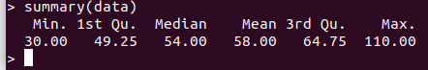

boxplot(data)

tab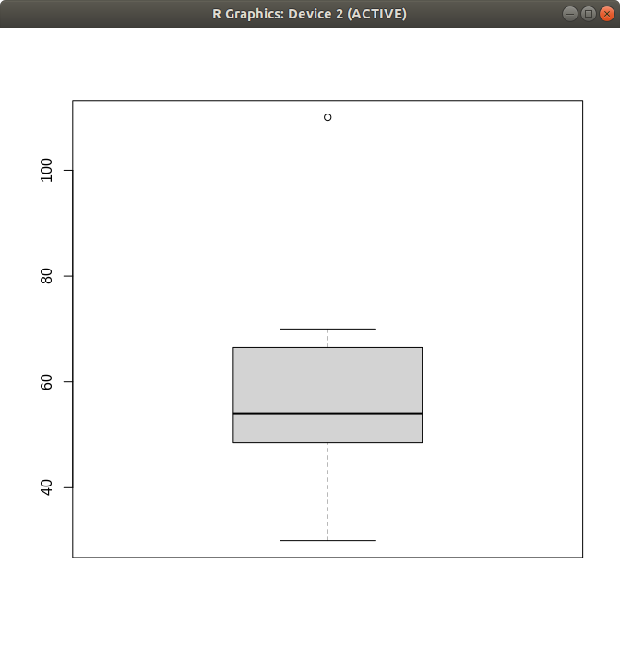

table(data)

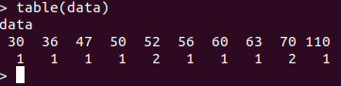

names(table(data))[table(data)==max(table(data))]



**#8**

**Histogram**

hist(data)

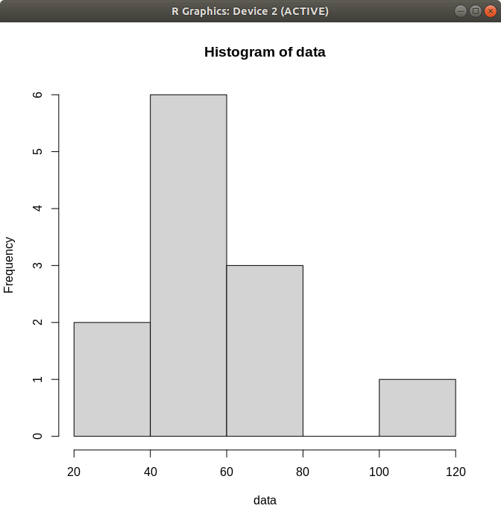

**#9**

**Scatter plot**

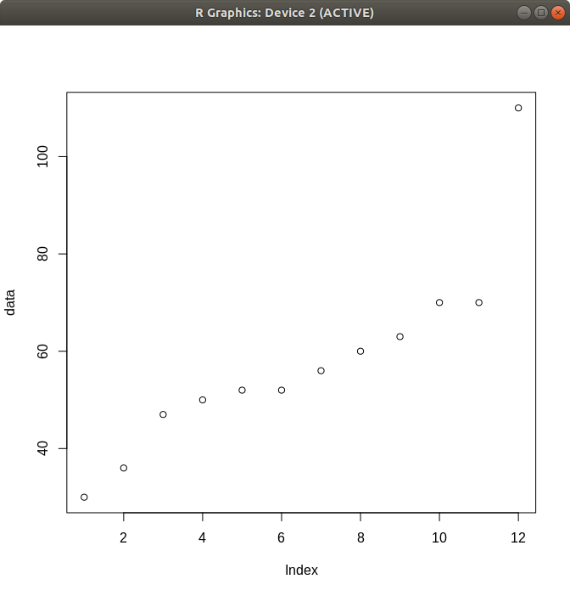

**#10**

**# Boxplot of MPG by Car Cylinders using the built-in mtcars dataset**

**boxplot(mpg ~ cyl, data = mtcars,**

**main = "Car Mileage Data",**

**xlab = "Number of Cylinders",**

**ylab = "Miles Per Gallon",**

**col = "lightblue")**

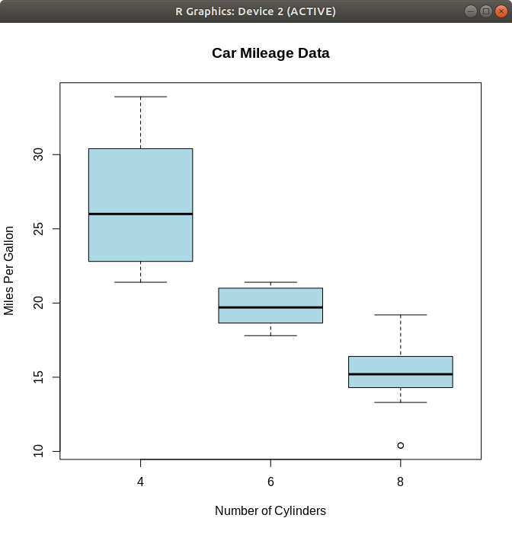

**#11**

**Distances**

Dissimilarity Matrix Calculation

Euclidean distances are root sum-of-squares of differences,

and manhattan distances are the sum of absolute differences.

library(cluster)

ll=matrix(c(22,20,1,0,42,36,10,8),ncol=4)

distances=daisy(ll,metric=c("euclidean"))

*square root ( square(22-20) + square(1-0) + square (42-36) + square(10-8) )*

*square root (4+1+36+ 4)*

*square root(45)*

*6.70*

distances=daisy(ll,metric=c("manhattan"))

*| 22-20| + |1-0| + |42-36| + |0-8|*

*2 + 1 + 6 + 2*

*11*

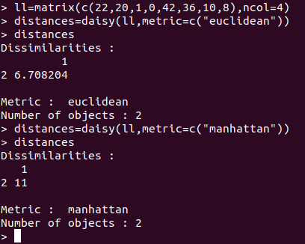

**Exercises on basic statistics API and pots:**

* Find out standard deviation
* Find out outliers theoretical and practically from your choice of observations and perform five-number summary using box plot/s
* Find out confusion matrix for your choice of
* Utilize cosine-similarity / Cosine measure
* Identify whether matrix is sparse or dense
* How do you detect noise in data?
* Draw QQ plot
* Prove by plot whether chosen dataset is symmetric or skewed (positive/negative)

Dataset

**nyc.csv**

Price,Food,Decor,Service,East

43,22,18,20,0

32,20,19,19,0

34,21,13,18,0

41,20,20,17,0

54,24,19,21,0

52,22,22,21,0

34,22,16,21,0

34,20,18,21,1

39,22,19,22,1

44,21,17,19,1

45,19,17,20,1

47,21,19,21,1

52,21,19,20,1

35,19,17,19,1

47,20,18,21,1

37,21,19,21,1

45,22,18,23,1

57,24,21,22,1

38,19,17,18,1

51,22,20,22,1

54,23,20,23,1

51,23,17,21,1

38,20,18,18,1

49,22,21,21,1

45,22,20,22,1

37,19,17,19,1

50,22,19,22,1

43,20,16,18,1

49,22,19,20,1

65,21,20,20,1

34,20,16,18,1

51,21,20,18,1

49,20,19,19,1

51,23,22,23,1

62,25,22,23,1

50,23,21,21,1

51,21,18,20,1

52,22,19,22,1

57,24,20,23,1

49,21,20,21,1

33,19,17,18,1

43,19,17,17,1

41,21,17,18,1

58,24,21,23,1

56,22,17,21,1

44,22,17,21,1

37,20,15,20,1

56,21,17,20,1

58,24,18,21,1

44,16,16,16,1

46,20,18,20,1

40,20,20,20,1

39,19,18,17,1

36,17,14,17,1

34,18,15,16,1

54,18,16,15,1

51,23,17,20,1

41,20,14,19,1

40,22,17,20,1

24,18,13,18,1

53,24,20,21,1

31,19,16,17,1

35,18,16,17,1

49,20,19,19,1

38,19,15,17,1

48,21,16,18,1

43,20,19,20,1

29,17,14,15,1

37,17,18,15,1

55,22,21,20,1

37,22,18,20,1

55,23,20,22,1

49,24,20,22,1

33,19,14,18,1

52,23,20,22,1

47,22,16,21,1

43,21,16,20,1

33,18,17,18,1

38,18,16,19,1

48,21,18,19,1

50,21,18,21,1

46,23,19,21,1

38,23,19,24,1

33,20,16,19,1

46,23,19,23,1

37,19,15,19,1

50,23,18,20,1

54,25,24,24,1

41,21,19,21,1

37,21,15,18,1

50,22,18,21,1

60,24,22,23,1

36,23,16,22,1

54,23,19,21,1

39,19,18,18,1

35,20,16,18,1

30,19,13,20,1

41,19,17,19,1

30,19,14,17,1

25,18,15,15,1

43,19,18,21,1

45,20,15,17,1

57,23,16,20,1

32,18,15,17,0

51,24,21,21,1

48,23,20,21,1

36,18,16,16,1

37,20,17,19,0

31,20,19,19,1

47,23,19,21,1

40,19,16,19,1

37,18,16,18,1

43,23,20,21,1

51,23,22,21,1

19,18,9,15,1

28,17,14,17,0

22,21,6,14,0

41,19,17,19,0

33,19,15,18,0

29,19,15,17,0

33,19,17,18,0

45,19,16,18,0

38,17,16,17,0

52,20,23,20,0

38,20,17,19,0

47,18,18,17,0

46,22,18,20,0

40,20,17,18,0

32,20,15,19,0

65,19,23,18,0

47,19,21,17,0

65,23,22,22,0

45,20,17,21,0

46,22,22,20,0

44,20,19,20,0

40,19,19,18,0

46,19,18,20,0

32,19,15,17,0

23,20,14,16,0

42,18,21,17,0

29,21,18,19,0

49,21,18,20,0

53,22,24,21,0

45,22,19,21,0

63,22,25,22,0

52,23,23,21,0

40,19,20,17,0

45,22,21,23,0

38,21,17,20,0

38,18,17,18,0

42,21,16,20,0

57,23,19,23,0

39,21,19,20,0

43,20,18,18,0

29,17,14,16,0

42,20,16,19,0

50,22,19,21,0

34,18,16,17,0

31,16,15,16,0

31,20,17,19,0

46,21,19,22,0

42,21,15,19,0

31,19,16,18,0

31,17,15,16,0

26,20,16,17,0

31,18,16,17,0

38,22,17,21,0

34,24,10,16,0

Dataset

**Cars (Dataset is available in R Shell by default)**

**cars**

speed dist

1 4 2

2 4 10

3 7 4

4 7 22

5 8 16

6 9 10

7 10 18

8 10 26

9 10 34

10 11 17

11 11 28

12 12 14

13 12 20

14 12 24

15 12 28

16 13 26

17 13 34

18 13 34

19 13 46

20 14 26

21 14 36

22 14 60

23 14 80

24 15 20

25 15 26

26 15 54

27 16 32

28 16 40

29 17 32

30 17 40

31 17 50

32 18 42

33 18 56

34 18 76

35 18 84

36 19 36

37 19 46

38 19 68

39 20 32

40 20 48

41 20 52

42 20 56

43 20 64

44 22 66

45 23 54

46 24 70

47 24 92

48 24 93

49 24 120

50 25 85

Dataset

mtcars **(Dataset is available in R Shell by default)**

> mtcars

mpg cyl disp hp drat wt qsec vs am gear carb

Mazda RX4 21.0 6 160.0 110 3.90 2.620 16.46 0 1 4 4

Mazda RX4 Wag 21.0 6 160.0 110 3.90 2.875 17.02 0 1 4 4

Datsun 710 22.8 4 108.0 93 3.85 2.320 18.61 1 1 4 1

Hornet 4 Drive 21.4 6 258.0 110 3.08 3.215 19.44 1 0 3 1

Hornet Sportabout 18.7 8 360.0 175 3.15 3.440 17.02 0 0 3 2

Valiant 18.1 6 225.0 105 2.76 3.460 20.22 1 0 3 1

Duster 360 14.3 8 360.0 245 3.21 3.570 15.84 0 0 3 4

Merc 240D 24.4 4 146.7 62 3.69 3.190 20.00 1 0 4 2

Merc 230 22.8 4 140.8 95 3.92 3.150 22.90 1 0 4 2

Merc 280 19.2 6 167.6 123 3.92 3.440 18.30 1 0 4 4

Merc 280C 17.8 6 167.6 123 3.92 3.440 18.90 1 0 4 4

Merc 450SE 16.4 8 275.8 180 3.07 4.070 17.40 0 0 3 3

Merc 450SL 17.3 8 275.8 180 3.07 3.730 17.60 0 0 3 3

Merc 450SLC 15.2 8 275.8 180 3.07 3.780 18.00 0 0 3 3

Cadillac Fleetwood 10.4 8 472.0 205 2.93 5.250 17.98 0 0 3 4

Lincoln Continental 10.4 8 460.0 215 3.00 5.424 17.82 0 0 3 4

Chrysler Imperial 14.7 8 440.0 230 3.23 5.345 17.42 0 0 3 4

Fiat 128 32.4 4 78.7 66 4.08 2.200 19.47 1 1 4 1

Honda Civic 30.4 4 75.7 52 4.93 1.615 18.52 1 1 4 2

Toyota Corolla 33.9 4 71.1 65 4.22 1.835 19.90 1 1 4 1

Toyota Corona 21.5 4 120.1 97 3.70 2.465 20.01 1 0 3 1

Dodge Challenger 15.5 8 318.0 150 2.76 3.520 16.87 0 0 3 2

AMC Javelin 15.2 8 304.0 150 3.15 3.435 17.30 0 0 3 2

Camaro Z28 13.3 8 350.0 245 3.73 3.840 15.41 0 0 3 4

Pontiac Firebird 19.2 8 400.0 175 3.08 3.845 17.05 0 0 3 2

Fiat X1-9 27.3 4 79.0 66 4.08 1.935 18.90 1 1 4 1

Porsche 914-2 26.0 4 120.3 91 4.43 2.140 16.70 0 1 5 2

Lotus Europa 30.4 4 95.1 113 3.77 1.513 16.90 1 1 5 2

Ford Pantera L 15.8 8 351.0 264 4.22 3.170 14.50 0 1 5 4

Ferrari Dino 19.7 6 145.0 175 3.62 2.770 15.50 0 1 5 6

Maserati Bora 15.0 8 301.0 335 3.54 3.570 14.60 0 1 5 8

Volvo 142E 21.4 4 121.0 109 4.11 2.780 18.60 1 1 4 2